**Unit 1: Algebraic Expressions**

**Lesson 1: Adding and Subtracting Polynomials**

**Objectives:**

* **I can translate verbal expressions**
* **I can simplify algebraic expressions**
* **I can add and subtract polynomials**

**Agenda:**

* **Groupwork 1**
* **Groupwork 2**
* **Video**
* **Practice**
* **Challenge yourself: Perimeter**

**Vocabulary:**

* **Monomial/Binomial/Trinomial/Polynomial/variable/Coefficient/Simplify/Like terms/constant/linear/quadratic/cubic/degree.**

**Focus Questions:**

1. **What is meant by “like terms”?**
2. **How do you find the sum and difference of polynomials?**

**Web support:**

* <https://www.khanacademy.org/math/algebra-basics/quadratics-polynomials-topic/polynomial-basics-core-algebra/v/terms-coefficients-and-exponents-in-a-polynomial>
* <https://www.khanacademy.org/math/algebra-basics/quadratics-polynomials-topic/polynomial-basics-core-algebra/v/adding-and-subtracting-polynomials-1>
* <https://www.khanacademy.org/math/algebra-basics/quadratics-polynomials-topic/polynomial-basics-core-algebra/v/adding-and-subtracting-polynomials-2>

**Online Practice:**

* <https://www.khanacademy.org/math/algebra-basics/quadratics-polynomials-topic/polynomial-basics-core-algebra/e/adding_and_subtracting_polynomials>
* <http://mathbitsnotebook.com/Algebra1/Polynomials/POBasicsPractice.html>
* <http://mathbitsnotebook.com/Algebra1/Polynomials/POAddPractice.html>
* <http://mathbitsnotebook.com/Algebra1/AlgebraicExpressions/AEexpressPractice.html>

**Homework: Finish your practice**

Group work 1

Use the following phrases that can be used in word problems to translate verbal expressions into mathematical expressions

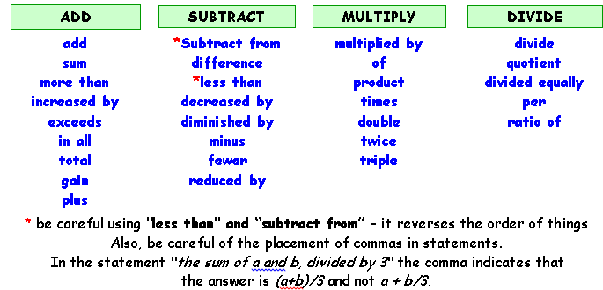

Example

|  |  |
| --- | --- |
| 1. | 5 more than a number $5+x$ |
|  |  |
| 2. | 6 times a number increased by 1 ________________ |
| 3. | Twice a number, diminished by 5 _____________ |
| 4. | 1 less than 6 times a number _________________ |
| 5. | 5 decreased by twice a number_________________ |
| 6. | Subtract a number from 6 _________ |
| 7. | Three more than five times a number. __________________________ |
| 8. | Twelve less than eight times a number. _________________________ |
| 9. | Twice a number decreased by seven. _____________________ |

Group work 2

Look at the table that Name Polynomials by degree and term and classify the following polynomials

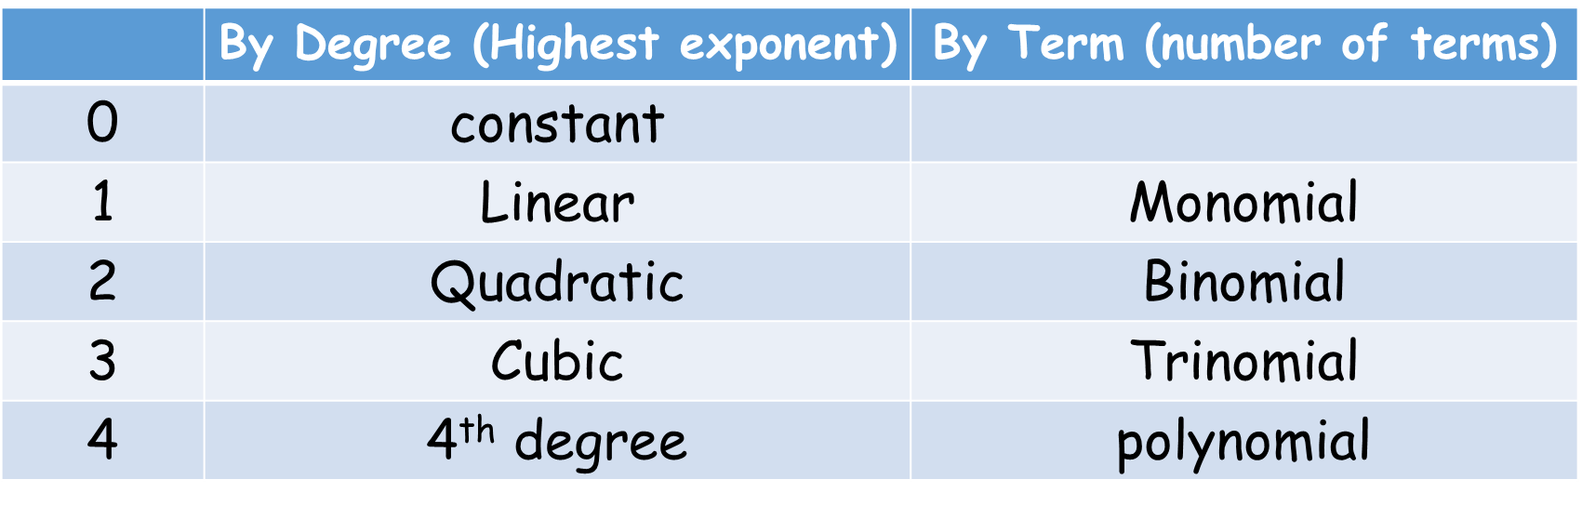

Example:

$–2x²–2x+7$ is a quadratic trinomial and the leading coefficient is -2 because -2 is the number multiplied by the variable with the highest exponent

Now is your turn, Name the following polynomials and identify the leading coefficient.

1. ${3x}^{2}+9$ 3. 7x²
2. 5x + 3x³ –2 4. 6

5.

7. 8. –2 + 4x

While watching video 1-1 : <https://youtu.be/-1Mxuqifo1k>

Answer the following question

1. Write down the steps necessary to add polynomials:
2. Write down the steps necessary to subtract polynomials:

**Practice:**

**Simplify the following expressions: We are not solving, look for like terms**

|  |  |
| --- | --- |
| 1. | 3. |
| 2. = | 4.  = |

**Now let’s work with some operations with these polynomials**

*Find the sum of the following expressions*

1. 
2. 
3. 
4. 

*Find the difference of the following Polynomials:*

1. 
2. 
3. 
4. **=**

**Let’s use all the skills together:**

1. *Subtract  from 
2. **From the following trinomialSubtract the following trinomial**
3. *Subtract $2x^{2}+3x+5$ from $6x^{2}-5x+3$
4. From the sum of $4x^{2}-2x+6$ and $2x^{2}+4x-1$   , subtract $5x^{2}+2x-4$

1. Simplify:

**Challenge yourself: Applied Problems: Perimeter**

**Perimeter is the sum of all sides**

1. **The side of square garden is represented by (x+3). What is the perimeter of the garden in terms of x?**
2. **2x+6 b) $x^{2}+9$ c) ${(x+3)}^{4}$ d) $4x+12$**
3. What expression represents the perimeter of the triangular soccer field figure below in the simplest form

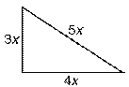

1. 60x b) ${60x}^{3}$ c) 12x d) $12x^{3}$
2. **What is the perimeter of the quadrilateral kitchen table in the diagram below?**

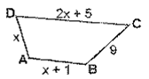

1. $2x^{3}+45$ b) $12x+6$ c) $3x+6$ d) $4x+15$
2. The Length of a rectangle is 8 and its width is represented by w. What is the perimeter of the rectangle in terms of w?



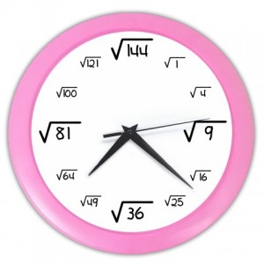

**Adding polynomials: Write down the rule and give an example**

**Like Terms: Define it and give an example**

**Subtracting Polynomials: Rule and example**

**Multiplying Polynomials**

**Dividing Polynomials**